Imperialism
Research Topic

Focus A: Political-state Building, Expansion, and Conflict

Focus B: Economic-Creation, Expansion and Environment

Step One: Create 3 essential questions for each of the focus topics. These questions will be the basis for your research.

Example: What imperial power government structure was the most successful at maintain control of the local population and why?

Step Two: Choose one essential question from each focus. These will be your research topics.

Step Three: Create a research map similar to the one I shared with you.

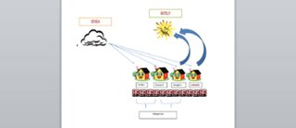

Step Four: Start doing research for your focus questions while using your research map to keep track of them.

